Day 14 - 02th July 2025

Task 1:

Create a custom node , add elements to it and traverse it..

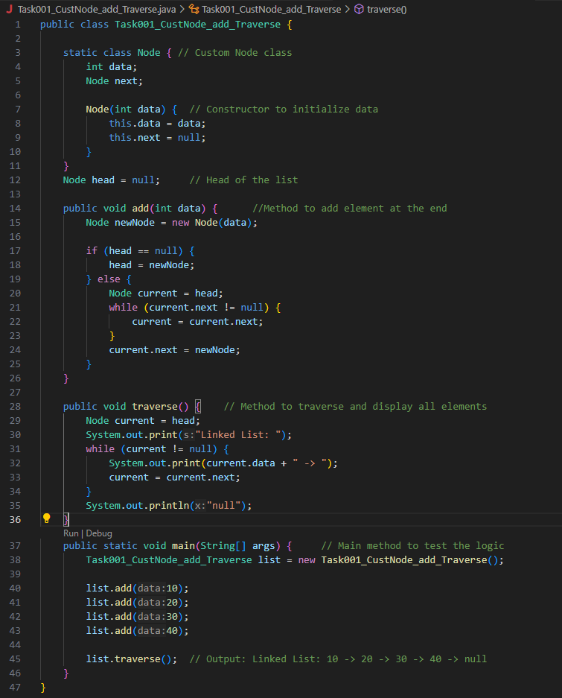
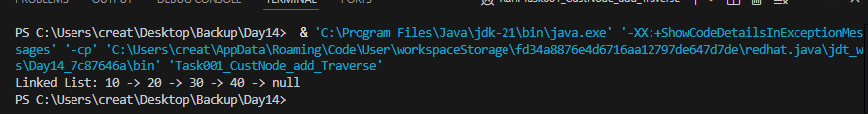

09.45 to 9.50

Task 2:
What do you understand by traversing elements in a linked list.

Traversing a linked list means visiting each node one by one from the start to the end in order to access or process the data stored in the list.

Do We Traverse a Linked List?
To print all elements
To search for a specific value
To count the number of nodes
To modify elements
To delete or insert at a specific position

How Traversal Works?
Start from the head node
While the current node is not null (or not back to head in a circular list):
Access current.data
Move to current.next

For a circular linked list, the loop continues until you circle back to the head.
For a doubly linked list, you can traverse both forward (next) and backward (prev).

Task 3:

Create a Circular Linked list using Task 1 Singly linked list.

class Node {

int value;
Node nextNode;

public Node(int value) {
this.value = value;
}
}

public class CircularLinkedList {
// if the list is empty
private Node head = null;
private Node tail = null;

// …..
}

public void addNode(int value) {
Node newNode = new Node(value);

if (head == null) {
head = newNode;
} else {
tail.nextNode = newNode;
}

tail = newNode;
tail.nextNode = head;
}

private CircularLinkedList createCircularLinkedList() {
CircularLinkedList cll = new CircularLinkedList();

cll.addNode(13);
cll.addNode(7);
cll.addNode(24);
cll.addNode(1);
cll.addNode(8);
cll.addNode(37);
cll.addNode(46);

return cll;
}
public boolean containsNode(int searchValue) {
Node currentNode = head;

if (head == null) {
return false;
} else {
do {
if (currentNode.value == searchValue) {
return true;
}
currentNode = currentNode.nextNode;
} while (currentNode != head);
return false;
}
}

public void deleteNode(int valueToDelete) {
Node currentNode = head;
if (head == null) { // the list is empty
return;
}
do {
Node nextNode = currentNode.nextNode;
if (nextNode.value == valueToDelete) {
if (tail == head) { // the list has only one single element
head = null;
tail = null;
} else {
currentNode.nextNode = nextNode.nextNode;
if (head == nextNode) { //we're deleting the head
head = head.nextNode;
}
if (tail == nextNode) { //we're deleting the tail
tail = currentNode;
}
}
break;
}
currentNode = nextNode;
} while (currentNode != head);
}

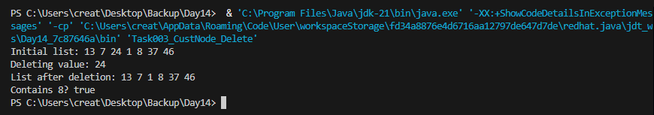

Stacks

Collection (interface ) ===> List (interface) ⇒ Vector class ===> Stacks (class)

Task 4 :

Stacks

Create a code to implement a stack
12.42 – plz complete..

import java.util.Stack;
class Ds_Stack_Push {
public static void main(String[] args) {
Stack<String> names= new Stack<>();

names.push("Prasunamba");
names.push("Meher");
names.push(".MK");

System.out.println("Stack of names: " + names);
}
}

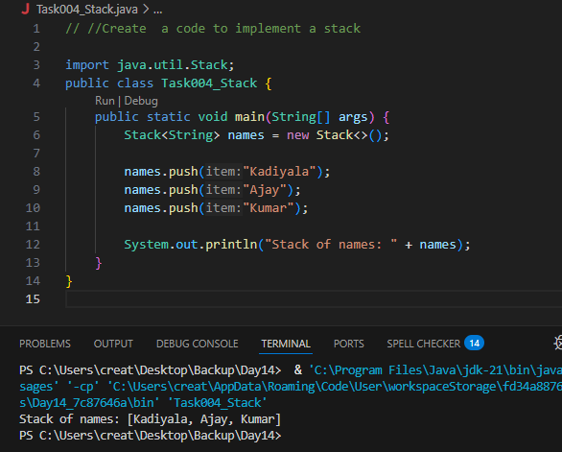

Task 5:

Create astack and pop the element also print the popped element.

12.50 plz complete

import java.util.Stack;
class Ds_Stack_Pop {
public static void main(String[] args) {
Stack<String> names= new Stack<>();

names.push("Prasunamba");
names.push("Meher");
names.push(".MK");

System.out.println("before deletion ");
System.out.println("Stack of names: " + names);

System.out.println("after deletion ");
String dummy = names.pop();

System.out.println("Stack of names: " + names);
System.out.println("deleted element is "+ dummy);
}
}

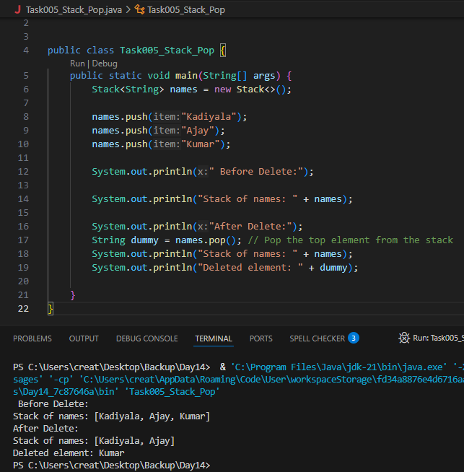

Task 6:

Find an element in the stack and display the position

Hint 👍
Int position = names.search(“value”);

import java.util.Stack;
class Ds_Stack_SearchPosition {
public static void main(String[] args) {
Stack<String> names= new Stack<>();

names.push("Prasunamba");
names.push("Meher");
names.push(".MK");

System.out.println("Stack of names: " + names);

String Val = "Meher";
int position = names.search(Val);

System.out.println("the searched value is at position " + position);
}
}

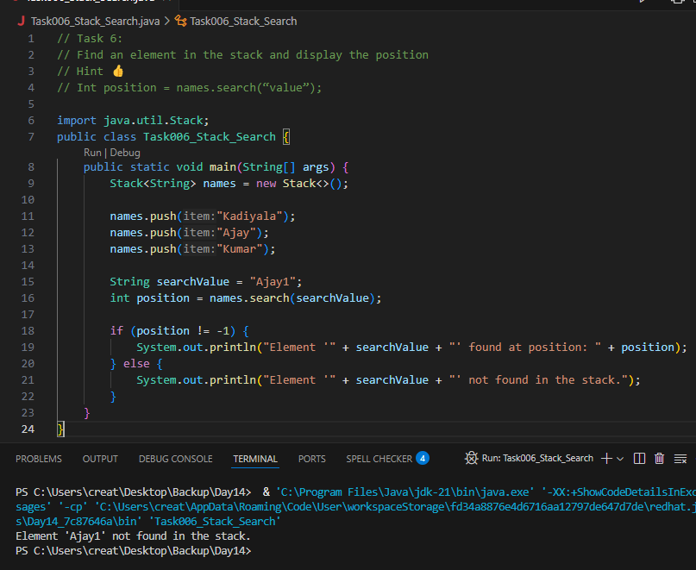

Task 7:

Peek the element and print it ..

import java.util.Stack;
class Ds_Stack_Peek {
public static void main(String[] args) {
Stack<String> names= new Stack<>();

names.push("Prasunamba");
names.push("Meher");
names.push(".MK");

System.out.println("Stack of names: " + names);

String topElement = names.peek();
System.out.println("The top element (without removal); "+ topElement);

System.out.println("Stack of names after peek operation " + names);
}
}

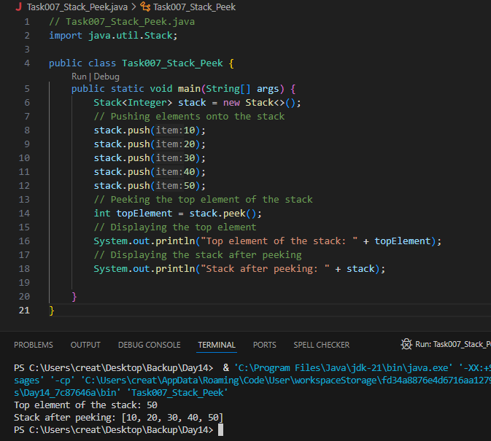

Task 8:

Check if the stack is empty or not?

import java.util.Stack;

public class Ds_Stack_Empty {
public static void main(String[] args) {
Stack<String> names = new Stack<>();
System.out.println("Is the stack empty? " + names.empty());

names.push("Prasunamba");
names.push("Meher");

System.out.println("Is the stack empty? " + names.empty());

while (!names.empty()){
System.out.println("Popped: " + names.pop());
}

System.out.println("Is the stack empty? " + names.empty());
}
}

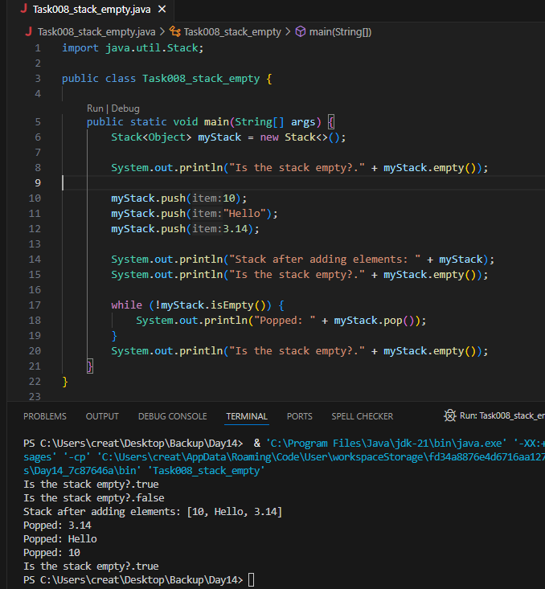
Task 9:

What are the methods of the stack class

The Stack class in Java is part of the java.util package and extends the Vector class. So it inherits methods from Vector and adds its own stack-specific methods.

Key Methods of the Stack Class

Stack-specific methods:
Method | Description
push(E item) | Pushes an item onto the top of the stack.
pop() | Removes and returns the top item from the stack.
peek() | Returns the top item without removing it.
search(Object o) | Returns the 1-based position from the top (or -1 if not found).
empty() | Returns true if the stack is empty (same as isEmpty()).

Inherited from Vector (useful ones):
Method | Description
isEmpty() | Checks if the stack is empty.
size() | Returns the number of elements in the stack.
get(int index) | Returns the element at specified position (indexing like an array).
clear() | Removes all elements from the stack.
contains(Object o) | Checks if an element exists in the stack.
elementAt(int index) | Similar to get(index)

Queues

Task 10:

What are the common operations in Queues
common operations in Queues, which are linear data structures that follow the FIFO principle — First In, First Out.

Common Queue Operations
Operation | Description
enqueue | Add an element to the rear (end) of the queue.
dequeue | Remove and return the element from the front of the queue.
peek / front | View the element at the front of the queue without removing it.
isEmpty | Check if the queue has no elements.
isFull | (In case of fixed-size queues) Check if the queue is full.
size | Returns the number of elements in the queue.
clear | Removes all elements from the queue.
contains | Checks if a specific element exists in the queue.

Task 11:

Wap to create a queue with custom methods
Is empty ()
Is full()
Enque
Deque
Peek
display()

15.40 to 15.52 to 16.34
8 pax done @ 16.34

public class Queue {
int queueLength = 3;
int items[] = new int[queueLength];
int front = -1;
int back = -1;

void enQueue(int itemValue) {
if(isFull()){
System.out.println("Queue is full");
} else if(front == -1 && back == -1){
front = back = 0;
items[back] = itemValue;
} else{
back++;
items[back] = itemValue;
}
}

void deQueue(){
if(isEmpty()){
System.out.println("Queue is empty. Nothing to dequeue");
} else if (front == back){
front = back = -1;
} else {
front++;
}
}

void display(){
int i;

if(isEmpty()){
System.out.println("Queue is empty");
} else {
for(i = front; i <= back; i++){
System.out.println(items[i]);
}
}
}

boolean isFull(){
if(back == queueLength - 1){
return true;
} else {
return false;
}
}

boolean isEmpty(){
if(front == -1 && back == -1){
return true;
} else {
return false;
}
}
void peek(){
System.out.println("Front value is: " + items[front]);
}
public static void main(String[] args) {
Queue myQueue = new Queue();
myQueue.enQueue(111);
myQueue.enQueue(222);
myQueue.enQueue(777);

myQueue.display();

myQueue.peek();
}

}

Add ons:

//converting stack and deque into a lists and printing their elements in java using streams.
import java.util.*;
import java.util.stream.Collectors;

class Stack_Deque_to_List.java {
public static void main (String[] args) {

Stack<Integer> stack = new Stack<>();
Deque<Integer> deque = new ArrayDeque<>();

stack.push(1);
deque.push(1);
stack.push(2);
deque.push(2);

List<Integer> list1 = stack.stream().collect(Collectors.toList());
System.out.println("Using Stack: ");
for(int i = 0; i < list1.size(); i++){
System.out.print(list1.get(i) + " " );
}
System.out.println();

List<Integer> list2 = deque.stream().collect(Collectors.toList());
System.out.println("Using Deque: ");
for(int i = 0; i < list2.size(); i++){
System.out.print(list2.get(i) + " " );
}
System.out.println();

}
}

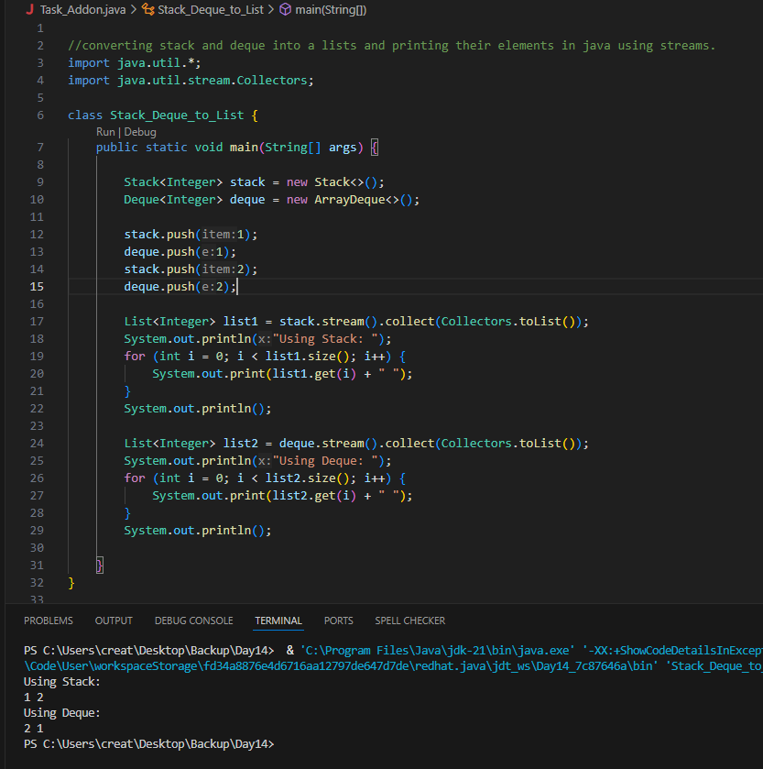
============================================================================================================================================

Home Tasks:

Recursion:

Wap to find the factorial of a number

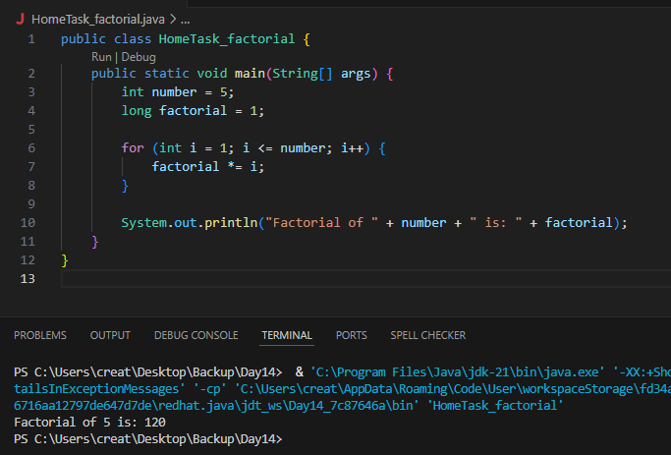

Wap to find the Fibonacci series of a number
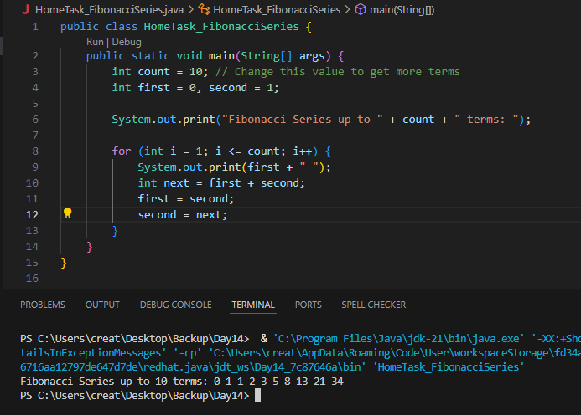

What is the difference between recursion and iteration

Iteration
- Definition: Repetition of a set of instructions using loops like for, while, or do-while.
- Control Flow: Uses loop variables and conditions to repeat.
- Memory Usage: Efficient—less memory consumed since it doesn’t rely on the call stack.
- Performance: Generally faster due to reduced overhead.
- Termination: Controlled explicitly through loop conditions.
Example
for (int i = 0; i < 5; i++) {
System.out.print(i + " ");
}

Recursion
- Definition: A function calls itself to solve smaller instances of a problem.
- Control Flow: Managed by the function itself through base and recursive cases.
- Memory Usage: Uses stack memory—each recursive call adds a new frame.
- Performance: Can be slower and may lead to StackOverflowError if not handled well.
- Termination: Requires a base case to avoid infinite recursion.
Example:
void printNumbers(int n) {
if (n == 0) return;
printNumbers(n - 1);
System.out.print(n + " ");
}

